CL3001
Computer Networks - Lab
Lab 10 & Week-10
Objectives:
- To establish persistent connections and create concurrent servers using TCP and UDP sockets.

Background
In previous labs, you implemented basic TCP and UDP communication where the server handled only one message and then stopped. In real-world applications like WhatsApp, web browsers, and online games, servers must:
- Stay alive and keep communicating with a client over multiple messages — this is called a Persistent Connection.
- Handle multiple clients at the same time — this is called a Concurrent Server.

Task 1 - NETWORK SETUP
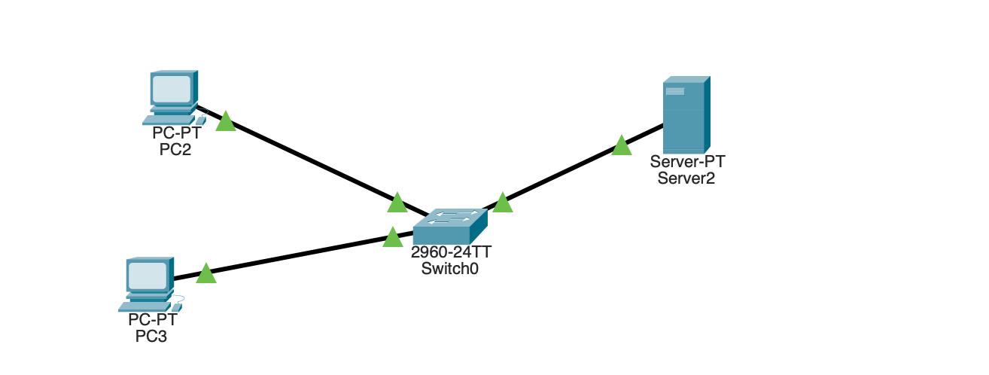
Step 1: Open Cisco Packet Tracer and create the following topology:
Place 1 Server device — assign IP: 192.168.1.2, Subnet Mask: 255.255.255.0 Place 2 PC devices:
PC0 — IP: 192.168.1.1 , Subnet Mask: 255.255.255.0
PC1 — IP: 192.168.1.3 , Subnet Mask: 255.255.255.0
Place 1 Switch — connect all three devices using Copper Straight-Through cables
Step 2: Verify connectivity — open Command Prompt on PC0 and type: Ping 192.168.1.2

Task 2 -Persistent TCP&UDP
What is a Persistent Connection?
In a persistent connection, the server does not close after receiving one message. It keeps listening and responding to multiple messages from the same client until the client decides to disconnect.

TCP Persistent
In this task, a TCP Persistent Server is set up in Cisco Packet Tracer. The Server listens on port 12000 and stays running even after receiving a message. PC0 connects to the Server and sends multiple messages one by one in a single session. The Server receives each message and sends a reply back to the client without closing the connection. This shows that a persistent connection allows multiple messages to be exchanged between the client and server without reconnecting each time.
Step 1 — Setup the Persistent TCP Server
- Click on Server0 → Go to Programming tab
- Click New → Select Empty Python → Name it main.py
- Paste your code
- Click RUN
Step 2 — Setup the Persistent TCP Client on PC0
- Click on Pc0 → Go to Programming tab
- Click New → Select Empty Python → Name it main.py
- Paste your code
- Click RUN

TCP Persistent

Client Side (PC0)
from tcp import *
from time import *
serverIP = '192.168.1.2'
port = 12000
client = TCPClient()

# Use list instead of global variable — Skulpt handles list mutation in callbacks
isConnected = [False]
def onReceive(data):
print("Server replied: " + data)
def onConnectionChange(type):
if type == 0:
isConnected[0] = True
print("Connected to server!")
if type == 1:
print("Disconnected from server.")
client.onReceive(onReceive)
client.onConnectionChange(onConnectionChange)
client.connect(serverIP, port)
print("Connecting...")
# Wait until callback confirms connection
count = 0
while not isConnected[0] and count < 20:
sleep(1)
count = count + 1
if isConnected[0]:
sleep(2)
print("Sending Message 1...")
client.send("Hello from Client! Message 1")
sleep(3)

print("Sending Message 2...")
client.send("Hello from Client! Message 2")
sleep(3)
print("Sending Message 3...")
client.send("Hello from Client! Message 3")
sleep(3)

print("All messages sent. Done.")
sleep(2)
else:
print("Connection failed.")

Server side
from tcp import *
from time import *
port = 12000
server = TCPServer()
message_count = 0
def onTCPNewClient(client):
print("Client connected: " + client.remoteIP())
def onTCPReceive(data):
global message_count
message_count = message_count + 1
print("Message " + str(message_count) + " received: " + data)
client.send("Server reply " + str(message_count) + ": Got your message!")
def onTCPConnectionChange(type):
if type == 0:
print("Client disconnected: " + client.remoteIP())
client.onReceive(onTCPReceive)
client.onConnectionChange(onTCPConnectionChange)
server.onNewClient(onTCPNewClient)
server.listen(port)
print("Persistent TCP Server listening on port 12000...")
while True:
sleep(1)

Must Answer These Questions
- In the previous lab, the server closed after one message. In this lab it does not. Which specific line in the server code keeps the server running persistently?
- The TCP connection in this lab goes through a 3-way handshake before data is exchanged. List the three steps of the handshake in order with direction (PC0 → Server or Server → PC0)
- Switch to Simulation Mode before running the client. Click Capture/Forward slowly. How many packets were exchanged BEFORE the first data message "Hello from Client! Message 1” was sent.
- In the PDU window, click on Layer 4. Write down the exact values you see.
- After each message is sent, do you see an ACK packet traveling back? What does this ACK confirm?

UDP Persistent
In this task, a UDP Persistent Server is set up in Cisco Packet Tracer. The Server listens on port 12001 and keeps running to receive multiple messages. PC0 sends multiple datagrams to the Server one by one without any connection setup. The Server receives each datagram, prints the message, and sends a reply back to the client. Since UDP has no connection, each message is sent independently but the Server stays active and handles all of them, which shows how UDP persistence works without any handshake or connection tracking.
Step 1 — Setup the Persistent UDP Server
- Click on Server0 → Go to Programming tab
- Click New → Select UDP Socket-Python → Name it main.py
- Paste your code
- Click RUN
Step 2 — Setup the Persistent UDP Client on PC0
- Click on Pc0 → Go to Programming tab
- Click New → Select UDP Socket-Python → Name it main.py
- Paste your code
- Click RUN
UDP Persistant
Server side
from udp import *
from time import *
message_count = 0
def onUDPReceive(ip, port, data):
global message_count
message_count = message_count + 1
print("UDP Message " + str(message_count) + " from " + ip + ": " + data)
socket.send(ip, port, "UDP Reply " + str(message_count) + ": Received!")
def main():
global socket
socket = UDPSocket()
socket.onReceive(onUDPReceive)
print(socket.begin(12001))
print("UDP Server listening on port 12001...")
while True:
sleep(1)

if __name__ == "__main__":
main()
Pc’s Side
from udp import *
from time import *
def onUDPReceive(ip, port, data):
print("Server replied: " + data)
def main():
socket = UDPSocket()
socket.onReceive(onUDPReceive)
socket.begin(12002)
print("UDP Client ready...")
sleep(2)
print("Sending UDP Message 1...")
socket.send("192.168.1.2", 12001, "UDP Hello! Message 1")
sleep(2)
print("Sending UDP Message 2...")
socket.send("192.168.1.2", 12001, "UDP Hello! Message 2")
sleep(2)
print("Sending UDP Message 3...")
socket.send("192.168.1.2", 12001, "UDP Hello! Message 3")
sleep(2)
print("All UDP messages sent. Done.")

if __name__ == "__main__":
main()

Output :
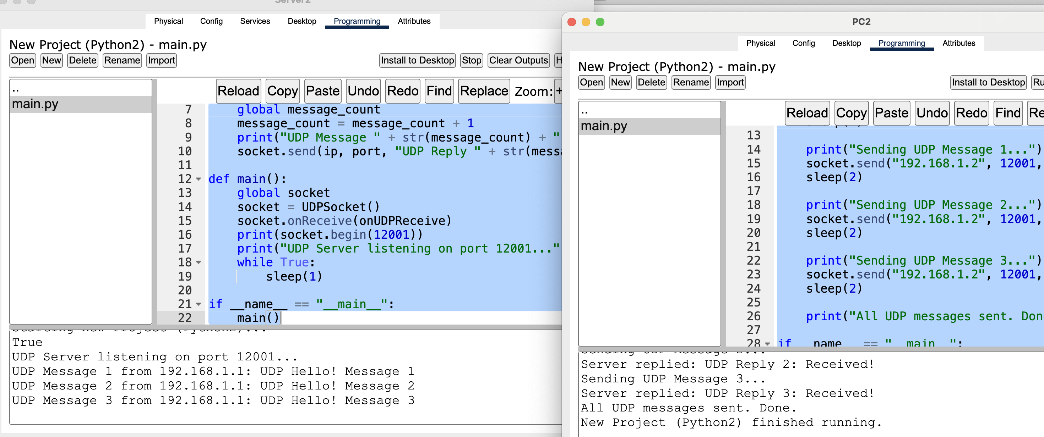

Must Answer These Questions
- In the TCP server, you saw Client connected: printed when a client joined. In the UDP server, there is no such message. Why?
- If a UDP packet is lost between PC0 and Server0 — what happens? Compare this with what would happen in TCP.
- Switch to Simulation Mode and run UDP. Open the PDU window and go to Layer 4. Compare with what you saw in TCP
- In UDP PDU Layer 4, is there a Sequence Number field like TCP? What does this tell you about UDP reliability?

Comparison: TCP vs UDP Persistent
Fill in the comparison table based on your observations
Feature | TCP Persistent | UDP Persistent
Connection setup required | Yes — 3-way handshake | ?
Server knows when client disconnects | Yes | ?
Packets guaranteed to arrive | Yes | ?
Sequence numbers in Layer 4 | Yes | ?
ACK packets visible in Simulation Mode | Yes | ?
Can handle multiple clients | Yes | ?
Port used in this lab | 12000 | ?
Speed | Slower | ?
Real-world use case | Web servers, Chat apps | ?

OSI Model Visualization
The best way to learn the OSI model is through Simulation Mode (bottom right icon).
• Place a PC and a Server, connect them with a Copper Straight-Through cable, and assign static IPs
(e.g., 192.168.1.1 and 192.168.1.2).
- Switch to Simulation Mode and click on the PC. Open the Web Browser and type the Server's IP.
- Click the "Capture/Forward" button. You will see an envelope (PDU).
- Click the PDU: A window opens showing the 7 Layers of the OSI Model. It will detail exactly what happens at Layer 4 (TCP segments), Layer 3 (IP packets), and Layer 2 (Ethernet frames).

Task 2 - Concurrent TCP&UDP Connection

TCP Concurrent
In this task, a TCP Concurrent Server is set up in Cisco Packet Tracer. The Server listens on port 12000 and waits for clients to connect. Two clients, PC0 and PC1, connect to the Server at the same time. Before sending any data, each client completes a TCP 3-Way Handshake with the Server — SYN, SYN-ACK, and ACK — which establishes a proper connection. After connecting, both PC0 and PC1 send multiple messages to the Server. The Server receives messages from both clients at the same time and sends a reply to each one separately without mixing up the responses. In the Server output, messages from PC0 and PC1 appear mixed together which confirms that the Server is successfully handling both clients simultaneously.

Must Answer These Questions
- How does the server differentiate between PC0 and PC1 when both are connected at the same time?
- In the Server output, messages from PC0 and PC1 appear mixed together. What does this confirm about the server?
- Switch to Simulation Mode and run both clients. Open the PDU window for PC0 and then for PC1. Compare:
- PC0 Source Port: _______________
- PC1 Source Port: _______________
- Both Destination Port: _______________
- Are source ports same or different? _______________

- Both PC0 and PC1 connect to the same Destination Port 12000. How does the server still know which reply to send to which client?
- Give one real-world example of a TCP Concurrent Server and explain why persistent connection is important in that example:

UDP Concurrent
In this task, a UDP Concurrent Server is implemented in Cisco Packet Tracer where the Server listens on port 12001 and two clients, PC0 and PC1, send messages to it simultaneously. When the Server receives the first datagram from any client, it replies with a personalized welcome message containing the client's IP address. Both PC0 and PC1 then continue sending multiple messages to the Server, and the Server handles all incoming datagrams concurrently — identifying each client by their IP address and port number and replying to each one independently. Since UDP has no connection state, no handshake is required before data is sent, making the Server naturally concurrent without any explicit connection tracking code. The interleaved messages from both clients visible in the Server output confirm that the Server is successfully handling multiple clients at the same time.

Must Answer These Questions
- The TCP Concurrent Server needed onTCPNewClient() callback to track each client. The UDP Concurrent Server has no such callback. Why does UDP not need this?
- PC0 used port 12002 and PC1 used port 12003. What would happen if both PCs used the same port 12002?
- Switch to Simulation Mode with only UDP filter active. Open a PDU from PC0 and another from PC1. Fill in:
- PC0 UDP Source Port: _______________
- PC1 UDP Source Port: _______________
- Destination Port: _______________
- Handshake visible: Yes / No
- In the Server output, messages from PC0 and PC1 appear interleaved. What does this confirm about UDP concurrent behavior?
- Give one real-world example where UDP Concurrent Server is used and explain why UDP is preferred over TCP in that case

